## STAT 3505 – Final Project Report

Team members: Elle Nguyen, Mary Le, Ting-An Andy Wang

### Project Overview:

The "normal" human body temperature of 98.6°F (37°C), which was established by Carl Wunderlich in the 19th century, has been a standard benchmark in medical practice. However, recent studies suggest that this value may be outdated and that it should be lower. This project aims to evaluate the validity of 98.6°F using dataset of body temperatures collected from a sample of 130 individuals. By employing hypothesis testing and various statistical analysis, our team will be able to investigate whether the true mean body temperature differs significantly from 98.6°F.

### Exploratory Data Analysis:

The dataset used in this project includes 130 observations, each with body temperature (°F), gender, and heart rate (bpm – beats per minute). By using **PROC MEANS** and **PROC FREQ**, we obtained descriptive statistics with the sample mean body temperature is 98.105°F (med=98.1°F, sd=0.699) for males and 98.394°F (med=98.4°F, sd=0.743) for females. The ratio of observations for males to females was 1:1, signifying that the dataset was evenly distributed. The null hypothesis ($H_{0}$) was that the population mean equals 98.6°F, while the alternative hypothesis ($H_{a}$) was that the population mean differs from 98.6°F.

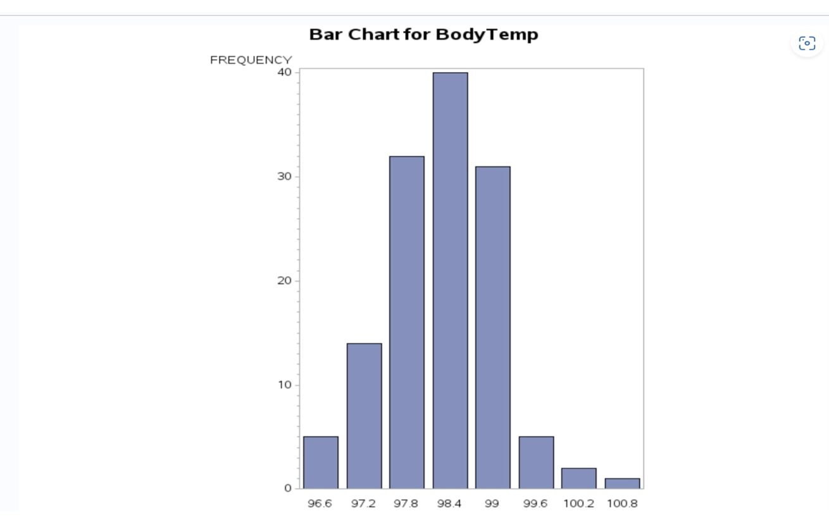

The bar chart for body temperature not only reveals the most common body temperature range among the participants, which predominantly falls between 98°F and 99°F but also highlights that our dataset does not contain any outliers.

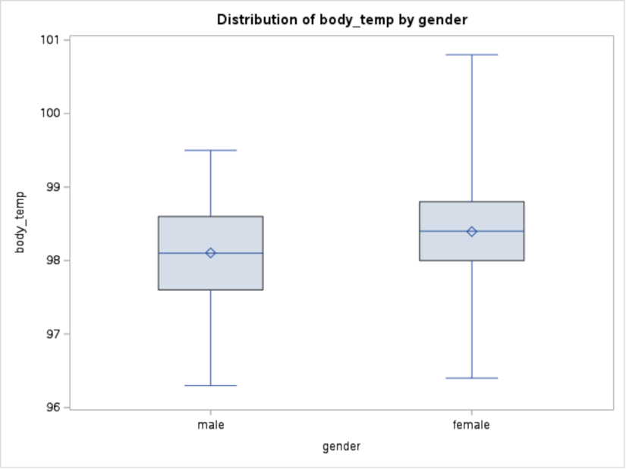

### Statistical Analysis:

A simple linear regression analysis was conducted using **PROC REG** to explore the relationship between heart rate and body temperature. The obtained regression equation was *Body Temperature = 96.307 + (0.0263 × Heart Rate)*. This equation suggests that for each one-unit increase in heart rate, the body temperature is expected to increase by 0.02633 degrees Fahrenheit, assuming the relationship between body temperature and heart rate is linear. Given the regression output, the p-value for the heart rate coefficient was 0.0036, indicating a statistically significant relationship between heart rate and body temperature. Despite this significance, the R-squared value of the model was 0.0643, which implies that only 6.43% of the variability in body temperature can be explained by changes in heart rate alone. The adjusted R-squared value at 0.0570 accounts for the number of predictors in the model, suggesting even less variability explained. Therefore, while our findings support the idea that heart rate does influence body temperature, heart rate is not a major factor in determining body temperature variations.

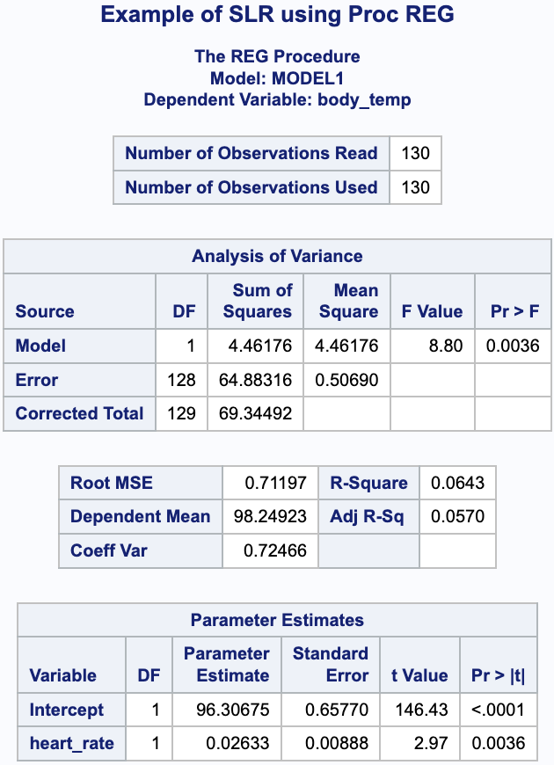

We also conducted a correlation analysis using **PROC CORR** to examine the relationship between body temperature and heart rate. The analysis yielded a correlation coefficient of 0.25366 with a p-value of 0.0036, indicating a weak but statistically significant positive correlation between body temperature and heart rate.

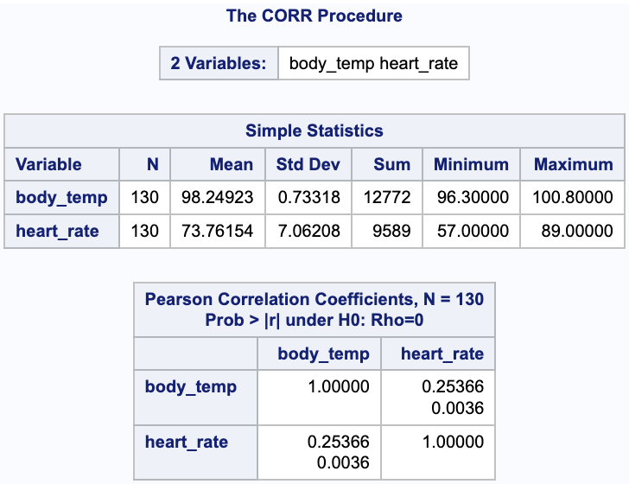

### Hypothesis Testing:

We assessed normality check using Q-Q plot of body temperature. Each point following closely to the projected line implied that the sample data supports a normally distributed population. While Q-Q plots indicate normality, we wanted to perform an additional normality test (Shapiro-Wilk) to reinforce our findings. With p = 0.2332 > 0.05 (the default alpha level), Shapiro-Wilk normality test also supported normal distribution.

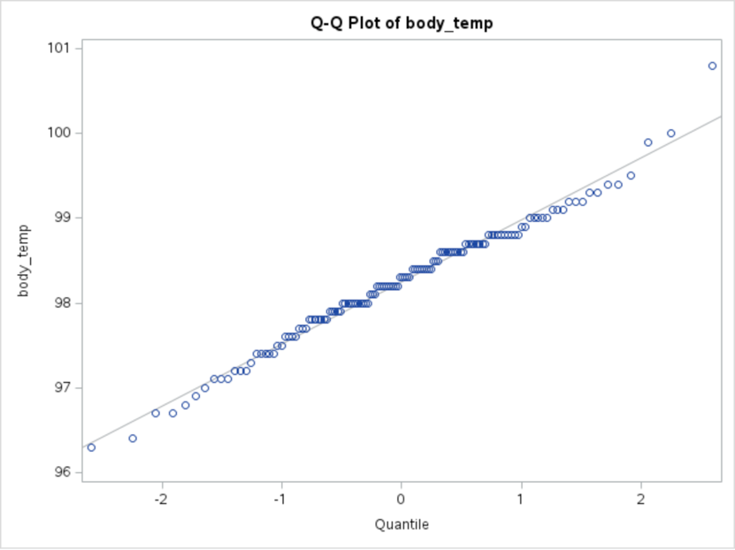

In addition to normality check, we also conducted a univariate analysis on body temperatures to test whether our hypothesized average body temperature lies within 95% confidence interval. The following figure shows that the mean is 98.24923 with 95% confidence limits from 98.122 to 98.37646. In other words, we are 95% confident that the true mean body temperature is between 98.12°F and 98.38°F and the hypothesized average body temperature, 98.6°F, is not included in the interval. Since this findings suggest that the true mean may differ from this value, we wanted to strengthen our conclusions using **One-sample t-Test**.

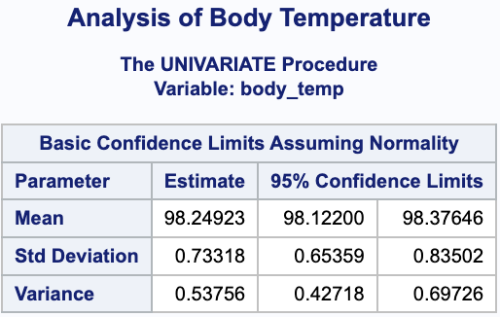

After conducting One-sample t-Test with our hypothesized mean of 98.6 for average body temperature (left-most snapshot), we obtained a significantly small p-value that was less than the default alpha level of 0.05 and came to a conclusion that we failed to reject the null hypothesis that the average body temperature is 98.6°F. However, as our previous findings from 95% confidence interval demonstrated that the actual mean is somewhere around 98.24923, we conducted another round of One-sample t-Test with a different hypothesized mean of 98.2 (right-most snapshot). This test yielded a better result with the p-value 0.4453 greater than the alpha level 0.05, meaning that we do not reject the null hypothesis of the new average body temperature of 98.2°F.

We can now conclude that the actual average body temperature is 98.2°F (which fits with more recent research) instead of 98.6°F (which was our original hypothesis).

### Conclusion:

The results of this study provide compelling evidence that the true average human body temperature is lower than the commonly accepted 98.6°F. This finding aligns with recent studies that have proposed lower average temperatures. The 95% confidence interval and t-test results support the conclusion that the population mean likely differs from 98.6°F.

Limitations of this study include the sample's potential lack of representativeness and the influence of factors such as age, time of day, and measurement method on body temperature. Future research could explore these variables and their relationship to body temperature.

In conclusion, our analysis suggests that the widely accepted average human body temperature of 98.6°F may not be accurate. The sample mean was significantly lower than 98.6°F, with a 95% confidence interval not containing this value. These findings contribute to the growing body of evidence indicating that the true population mean body temperature is lower than the historical standard. Further research is needed to better understand the factors influencing body temperature and to update our understanding of what constitutes a "normal" temperature.

### References:

1. Dataset background: <https://jse.amstat.org/v4n2/datasets.shoemaker.html>
2. Project inspiration: <https://walton.uark.edu/enterprise/exercises-usecases-labs/files/sas/sas5eg_update.pdf>
3. Dataset source: <https://www.openintro.org/data/index.php?data=thermometry>